**Basics of Shell Scripting**

**1) Write a simple Bash program to get the following system variables:**

**a. pwd**

 **b. logname**

**2) Write a simple Bash program:**

**a. To ask username from user**

**b. Exit the program, if user does not enter anything within 10 second**

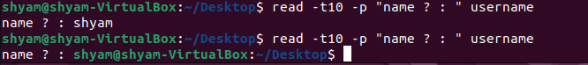 **Hint: read -t 10 -p**